**AIDS Lab**

**EXPERIMENT NO. 12**

**Aim**: Analysis and comparison of different Machine learning and Deep learning algorithms.

**Theory**:

**Machine Learning**

Machine learning (ML) is a type of artificial intelligence (AI) that allows software applications to become more accurate at predicting outcomes without being explicitly programmed to do so. Machine learning algorithms use historical data as input to predict new output values. Recommendation engines are a common use case for machine learning. Other popular uses include fraud detection, spam filtering, malware threat detection, business process automation (BPA) and Predictive maintenance.

**Types of Machine Learning**

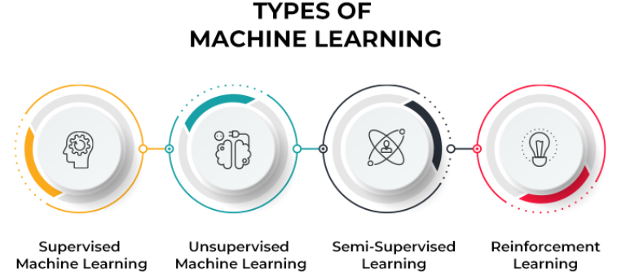

Classical machine learning is often categorised by how an algorithm learns to become more accurate in its predictions. There are four basic approaches: supervised learning, unsupervised learning, semi-supervised learning and reinforcement learning. The type of algorithm data scientists choose to use depends on what type of data they want to predict.

1. Supervised learning
2. Unsupervised learning
3. Semi-supervised learning
4. Reinforcement learning

**Support Vector Machine**

Support Vector Machine or SVM is one of the most popular Supervised Learning algorithms, which is used for Classification as well as Regression problems. However, primarily, it is used for Classification problems in Machine Learning. The goal of the SVM algorithm is to create the best line or decision boundary that can segregate n-dimensional space into classes so that we can easily put the new data point in the correct category in the future.

This best decision boundary is called a hyperplane. SVM chooses the extreme points/vectors that help in creating the hyperplane. These extreme cases are called support vectors, and hence the algorithm is termed as Support Vector Machine. Consider the below diagram in which there are two different categories that are classified using a decision boundary or hyperplane:

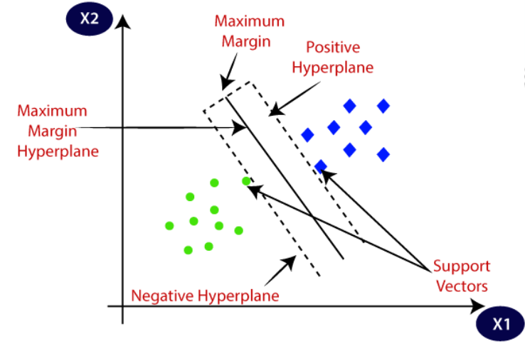

**K-Means Algorithm**

K-Means Clustering is an Unsupervised Learning algorithm, which groups the unlabeled dataset into different clusters. Here K defines the number of predefined clusters that need to be created in the process, as if K=2, there will be two clusters, and for K=3, there will be three clusters, and so on. It allows us to cluster the data into different groups and a convenient way to discover the

categories of groups in the unlabeled dataset on its own without the need for any training.

It is a centroid-based algorithm, where each cluster is associated with a centroid. The main aim of this algorithm is to minimize the sum of distances between the data point and their corresponding clusters. The algorithm takes the unlabeled dataset as input, divides the dataset into k-number of clusters, and repeats the process until it does not find the best clusters. The value of k should be predetermined in this algorithm. The k-means clustering algorithm mainly performs two tasks:

1. Determines the best value for K center points or centroids by an iterative process.
2. Assigns each data point to its closest k-center. Those data points which are near to the particular k-center, create a cluster.

Hence each cluster has datapoints with some commonalities, and it is away from other clusters.

The below diagram explains the working of the K-means Clustering Algorithm:

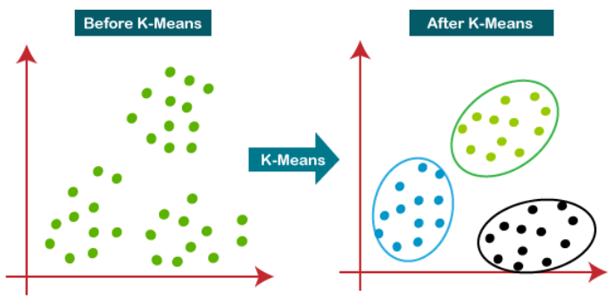

**Logistic Regression**

Logistic Regression was used in the biological sciences in the early twentieth century. It was then used in many social science applications. Logistic Regression is used when the dependent variable(target) is categorical. For example:

1. To predict whether an email is spam (1) or (0)
2. Whether the tumour is malignant (1) or not (0)

Consider a scenario where we need to classify whether an email is spam or not. If we use linear regression for this problem, there is a need for setting up a threshold based on which classification can be done. Say if the actual class is malignant, predicted continuous value 0.4 and the threshold value is 0.5, the data point will be classified as not malignant which can lead to serious consequences in real time.

From this example, it can be inferred that linear regression is not suitable for classification problems. Linear regression is unbounded, and this brings logistic regression into picture. Their value strictly ranges from 0 to 1.

Output -> 0 or 1

Hypothesis -> Z = WX + B

hΘ(x) -> sigmoid (Z)

Sigmoid Function

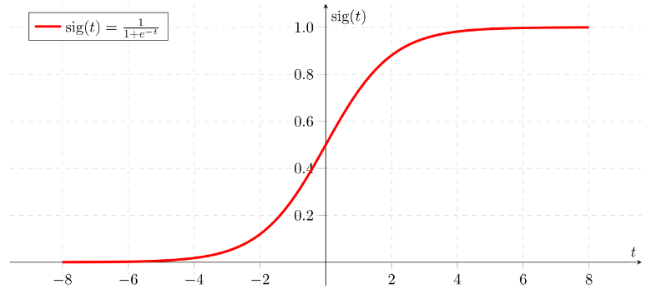

**Deep Learning**

Deep learning is a machine learning technique that teaches computers to do what comes naturally to humans: learn by example. Deep learning is a key technology behind driverless cars, enabling them to recognize a stop sign, or to distinguish a pedestrian from a lamppost. It is the key to voice control in consumer devices like phones, tablets, TVs, and hands-free speakers. Deep learning is getting lots of attention lately and for good reason. It’s achieving results that were not possible before.

In deep learning, a computer model learns to perform classification tasks directly from images, text, or sound. Deep learning models can achieve state-of-the-art accuracy, sometimes exceeding human-level performance. Models are trained by using a large set of labelled data and neural network architectures that contain many layers.

**Examples of Deep Learning at Work**

Deep learning applications are used in industries from automated driving to medical devices.

1. **Automated Driving**: Automotive researchers are using deep learning to automatically detect objects such as stop signs and traffic lights. In addition, deep learning is used to detect pedestrians, which helps decrease accidents.
2. **Aerospace and Defence**: Deep learning is used to identify objects from satellites that locate areas of interest, and identify safe or unsafe zones for troops.
3. **Medical Research**: Cancer researchers are using deep learning to automatically detect cancer cells. Teams at UCLA built an advanced microscope that yields a high-dimensional data set used to train a deep learning application to accurately identify cancer cells.
4. **Industrial Automation**: Deep learning is helping to improve worker safety around heavy machinery by automatically detecting when people or objects are within an unsafe distance of machines.
5. **Electronics**: Deep learning is being used in automated hearing and speech translation. For example, home assistance devices that respond to your voice and know your preferences are powered by deep learning applications.

**Types of Deep Learning algorithms**

1. Convolutional Neural Networks (CNNs)
2. Long Short Term Memory Networks (LSTMs)
3. Recurrent Neural Networks (RNNs)
4. Generative Adversarial Networks (GANs)
5. Radial Basis Function Networks (RBFNs)
6. Multilayer Perceptrons (MLPs)
7. Self Organizing Maps (SOMs)
8. Deep Belief Networks (DBNs)
9. Restricted Boltzmann Machines( RBMs)
10. Autoencoders

**Convolutional Neural Networks (CNNs)**

In deep learning, a convolutional neural network (CNN/ConvNet) is a class of deep neural networks, most commonly applied to analyse visual imagery. Now when we think of a neural network we think about matrix multiplications but that is not the case with ConvNet. It uses a special technique called Convolution. Now in mathematics convolution is a mathematical operation on two functions that produces a third function that expresses how the shape of one is modified by the other.

CNN have multiple layers that process and extract features from data:

1. **Convolution Layer**: CNN has a convolution layer that has several filters to perform the convolution operation.
2. **Rectified Linear Unit (ReLU)**: CNN has a ReLU layer to perform operations on elements. The output is a rectifier feature map.
3. **Pooling Layer**: The rectified feature map next feeds into a pooling layer. Pooling is a down-sampling operation that reduces the dimensions of the feature map. The pooling layer then converts the resulting two-dimensional arrays from the pooled feature map into a single, long, continuous, linear vector by flattening it.
4. **Fully Connected Layer**: A fully connected layer forms when the flattened matrix from the pooling layer is fed as an input, which classifies and identifies the images.

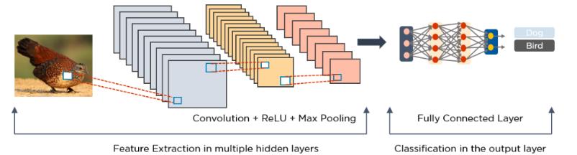

**Long Short Term Memory Networks (LSTMs)**

LSTMs are a type of Recurrent Neural Network (RNN) that can learn and memorize long-term dependencies. Recalling past information for long periods is the default behavior. LSTMs retain information over time. They are useful in time-series prediction because they remember previous inputs. LSTMs have a chain-like structure where four interacting layers communicate in a unique way. Besides time-series predictions, LSTMs are typically used for speech recognition, music composition, and pharmaceutical development. LSTMs work as following:

1. First, they forget irrelevant parts of the previous state
2. Next, they selectively update the cell-state values
3. Finally, the output of certain parts of the cell state

Below is a diagram of how LSTMs operate:

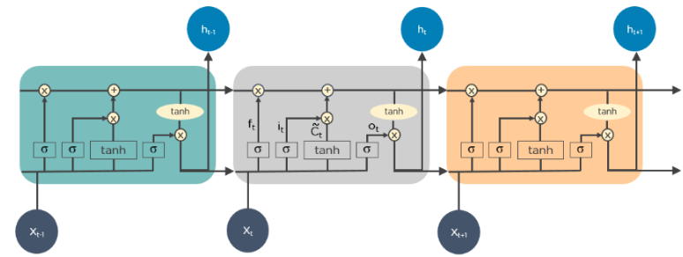

**Recurrent Neural Networks (RNNs)**

RNNs have connections that form directed cycles, which allow the outputs from the LSTM to be fed as inputs to the current phase. The output from the LSTM becomes an input to the current phase and can memorize previous inputs due to its internal memory. RNNs are commonly used for image captioning, time-series analysis, natural-language processing, handwriting recognition, and machine translation. An unfolded RNN looks like this:

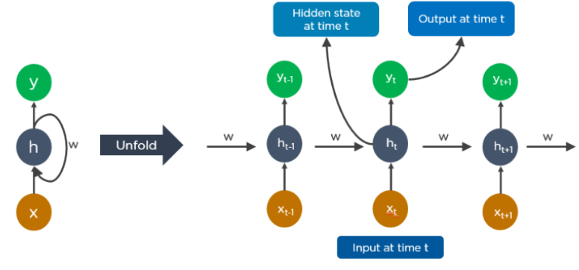

RNN work as following:

1. The output at time t-1 feeds into the input at time t.
2. Similarly, the output at time t feeds into the input at time t+1.
3. RNNs can process inputs of any length.
4. The computation accounts for historical information, and the model size does not
5. increase with the input size.

**Conclusion**:

Thus we studied an overview of the analysis and comparison of different Machine learning and Deep learning algorithms.